ANNEX I
Technical Specifications and Quantities
of Goods to be supplied
(Model detail to be attached to the Bid Submission Form)

TABLE 1: Offer to Comply with Technical Qualification

Ref | Minimum Technical Specifications of goods required | Qty | Yes/No | Technical Specifications of goods to be offered
1 | Water Level Measurement
1.1 | Water Level Measurement (on river bank)  - Measurement range of 0-30 m.  - Resolution 1 mm.  - Accuracy ±5 mm.  - Measurement time: at least every 1 minute.  - Operating temperature range: 0° to + 60°C.  - Able to connect with a measuring tube or cable to the sensor for a minimum of 100 m long and must be installed unbroken from the sensor to the data logger.  - Must operate with Solar Power and auxiliary battery.  - If not OTT brand, ensure to be compatible with other OTT equipment and system used in the existing MRC hydromet stations  - Warranty: 2 years  Example of spare part’s picture  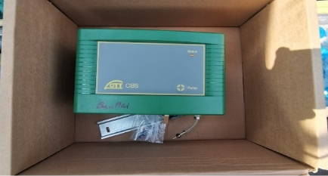 | 14 sets |  | Brand name:  Model:
1.2 | Water Level Measurement(on the bridge)  - Measurement range of approx. 0.5 - 30 m.  - Non-contact pulse radar.  - Resolution 2 mm.  - Accuracy: 5 mm.  - Measuring time: at least every 1 minute.  - Operating temperature: 0 to +60 °C.  - Data line for the equipment: minimum 200 m long and must be able to connect to a Data Logger.  - Must operate with Solar Power and auxiliary battery.  - If not OTT brand, ensure to be compatible with other OTT equipment and system used in the existing MRC hydromet stations  - Warranty: 2 years  Example of spare part’s picture  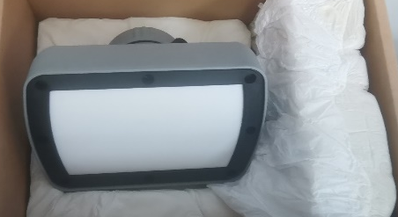 | 5 sets |  | Brand name:  Model:
2 | Data Logger  - Capable of recording and storing data from both water level and rainfall sensors and other water quality parameters such as conductivity, dissolved oxygen, pH, Turbidity and water temperature, up to at least 10 parameters (current system contains 8 parameters).  - Minimum storage capacity of 1 year of data.  - Remote communication capabilities for real-time data transmission to a central database at the MRC premise and cloud database.  - Ability to operate in a harsh environment, with protection against extreme temperatures, humidity, and power fluctuations.  - Ability to connect or to be compatible with other OTT sensors that are currently installed in the existing station.  - Operating system: real-time operating system with power management for minimal power consumption.  - If not OTT brand, ensure to be compatible with other OTT equipment and system used in the existing MRC hydromet stations  - Warranty: 2 years  Example of spare part’s picture  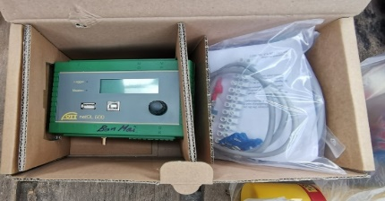 | 14 sets |  | Brand name:  Model:
3 | Measuring Tube/Gas Tube  - Capable to connect with the system of water level measurement (between OTT CBS Bubble sensor for water level measurement and Bubble chamber EPS 50) for a minimum of 100 m long  - Warranty: 2 years  Example of spare part’s picture  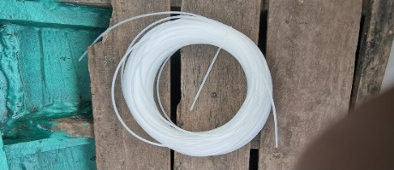 | 12 sets |  | Brand name:  Model:

TABLE 2: Offer to Comply with Other Conditions and Related Requirements

Ref | Other Conditions and Related Requirements | Your Response
Ref | Other Conditions and Related Requirements | Yes, we comply | No, we cannot comply
1 | Submission form duly signed by authorized person- Form of Annex II
2 | Copy of Certificate of business registration
3 | Quotation validity: at least 45 days
4 | Supplier Declaration Form (signed with date) – Form of Annex IV
5 | Expected delivery 8 weeks
6 | Bid Security in amount of USD 15,000 with validity beyond 4 weeks of bid expiry date

Signature and stamp : _______________
Name on behalf of Supplier: _______________
Title: ____________________________________

ANNEX II

[Insert Supplier logo and letterhead]

BID SUBMISSION FORM

To: Mekong River Commission Date:
Procurement Office Ref. No.:

Dear Mr. Phetsamone Khanophet,
Administration Division Director

Subject: Supply of ………………..

Having examined the Request for Quotation by Email (or published in the MRCS website) dated dd/mm/yy, the receipt of which is hereby duly acknowledged, we, the undersigned, offer to supply ………………….. in conformity with the required specifications in the Request for quotation.

We undertake, if our Quotation is accepted, to deliver the goods in accordance with our offered terms of conditions as informed below.

Our quotation is valid until: [please insert the date (at least for 45 days after the deadline for submission of quotations)].

We understand you are not bound to accept any submission you receive.

We remain,

Yours sincerely,

Authorised Signature [In full and initials]: ____________________

Name and Title of Signatory: ______________________________

Name of Firm: __________________________________________

Address:_______________________________________________

ANNEX IV

SUPPLIER DECLARATION FORM

As an important and highly visible inter-governmental organization the Mekong River Commission Secretariat (MRCS) has a special obligation to ensure that its mission is performed to the highest standards. To this end, a Fraud Prevention and Anti-Corruption (FPAC) Mechanism (as provided to bidders) has been adopted that applies to the MRCS activities and those involved in it. The FPAC Mechanism includes a commitment to ensuring that opportunities for fraud and corruption are reduced to the lowest possible level of risk.

As part of the risk mitigation and due diligence processes set out in the FPAC Mechanism, the MRCS requires all prospective service providers and their legal representatives to undertake that they shall comply with the standards set out in the FPAC Mechanism.

Full Name of Individual/Entity:
Current Business Natures | ☐ Water Resource Management (WRM) and Development Services  ☐ Consultancy services including Research on WRM  ☐ Training Services  ☐ Communication, PR, Advertisement |  | ☐ Research Institution or Development  Studies  ☐ Freelancer/general consultancy  ☐ Others (please specify):
Key Detail of the Current Business:

Business Structure (if applicable):  ☐ Partnership  ☐ Join Venture  ☐ Limited Liability  ☐ Company Corporation  ☐ None of the above |  | Business Type:  ☐ For Profit  ☐ Non-Profit (NGO)  ☐ Public Entity  ☐ Community Based Organization (CBO)  ☐ Private business
Registration or Formation of business (if applicable): | Country/State:
Registration or Formation of business (if applicable): | Time of registration (date/month/year):
Registration or Formation of business (if applicable): | Percentage of Ownership:
Registration or Formation of business (if applicable): | Business license number:
The entity/person identified above here by declares and/or confirms that the entity/person including any person having powers of representation, decision-making or control over them or a member of their administrative, management or supervisory body:

- has not been sentenced by final judgment on one or more of the following charges: participation in a criminal organization, corruption, fraud, money laundering, terrorist financing, terrorist offences or offences linked to terrorist activities, child labour or trafficking in human beings;

- is not in a situation of bankruptcy, liquidation, termination or suspension of business activities, insolvency or arrangement with creditors or any like situation arising from a procedure of the same kind, or is subject to a procedure of the same kind;

- has not received a judgment with res judicata force, finding an offence that affects their professional integrity or serious professional misconduct, including but not limited to: misrepresenting information required for the verification of the absence of grounds for exclusion or in the performance of a contract; entering into agreement with other persons or entities with the aim of distorting competition; violating intellectual property rights; attempting to influence the decision-making process of a contracting authority; or attempting to obtain confidential information;

- has complied and continues to comply with their obligations as regards payment of taxes, social security contributions and dues, according to the applicable statutory provisions;

- is not an entity created to circumvent tax, social or other legal obligations (empty shell company), have ever created or are in the process of creation of such an entity;

- has not been involved in mismanagement or other irregularities related to the use of MRC funds or public funds of another source;

- is not in a situation of conflict of interest in relation to the procurement process and any resulting contract;

- none of its officers, employees or subcontractors has or have been sanctioned for any offence listed in this Declaration Form;

- understands the provisions of the MRC FPAC Mechanism and has not and shall not be involved in any activities that are inconsistent with the standards of conduct set out in the FPAC Mechanism;

- if shortlisted, shall treat as confidential any information provided to it by the MRC Secretariat;

- understands that the MRC Secretariat may publish the name of shortlisted bidders in accordance with the provisions of the MRC Procurement Manual;

- understands that should circumstances pertaining to this Supplier Declaration Form change or new information emerge prior to the award of the goods or services to be procured then the entity/person is under an obligation to bring such information to the MRC Secretariat’s attention forthwith.

Consent: | Agrees to the MRC rules for protection of personal data. |  |  | Yes ☐ | No ☐
Consent: | Agrees to the MRC publishing information regarding the bidder in accordance with its Procurement Manual. |  |  | Yes ☐ | No ☐
Consent: | Agrees to the MRC’s established rules and regulations, and disciplinary measures will be undertaken as per terms and condition set in the contract should any violation occurred. |  |  | Yes ☐ | No ☐
Signature and Date: | I declare, on behalf of the entity or myself, that I have the power to represent the entity in making the declarations contained in this Supplier Declaration Form, that to the best of my knowledge the statements made in this Supplier Declaration Form are complete, true and correct and undertake to provide verification for any information that the MRC Secretariat may request:

