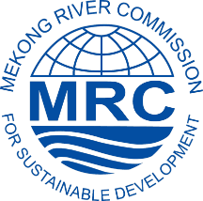
Registration of Interest
Regional Stakeholder Forum on the Council Study
and the Pak Beng Hydropower Project

Name: ………………………………………………………………………………………………..

Organization/association: ……………………………………………………………………………

Type of your organization/association: ……………………………………………………………….

Address:……………………………………………………………………………………………….

Tel/Fax/Email:…………………………………………………………………………………………

Indicate if request a sponsorship for travel support/reason?:…………………………………………..
…………………………………………………………………………………………………………
…………………………………………………………………………………………………............
Indicate if you need a desk for publication display……………………………………………………
………………………………………………………………………………………………………....

Please return the filled form by 10 Feb 2017 to:
Ms. Varaphone Silaphet
Secretary of Planning Division, Office of the Secretariat in Vientiane (OSV)
Tel: (856-21) 263263 Ext: 2115 | Email: varaphone@mrcmekong.org

