Mekong+
  - New Frontiers in Sustainable Hydropower Development
Hydropower Sustainability Forum
Oslo, Norway 4-6 September 2017
Final Concept Note
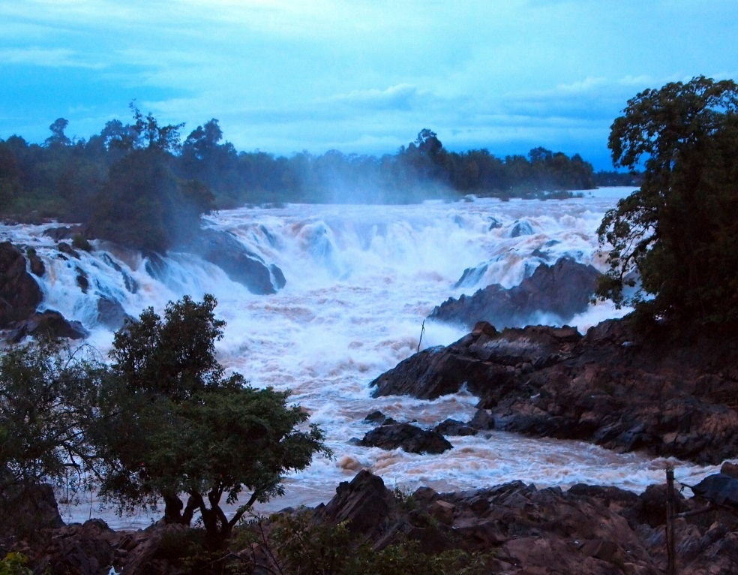
Khone Falls, Mekong River, Lao PDR (Photo: Kristine Walløe-Lilleeng)
  - Background
Sustainable Hydropower Development has gained accelerated momentum worldwide since the Millennium shift and will also be an important source for reaching the UN Sustainable Development Goal (SDG) number 7 aiming at affordable and clean energy for all. If carefully planned and implemented in an integrated water resources management framework, working towards affordable and clean energy can contribute to both SDG 6 (Water and Sanitation for all) and SDG 5 (gender equality) by empowering women and girls through easier energy access.
Multilateral and bilateral international financing institutions have a growing investment portfolio where sustainability policies, guidelines, and safeguards are at the core of project planning and implementation. Similarly, the involvement of the private sector and facilitation of public-private partnerships is growing. This New Frontier in hydropower development is reflected in initiatives by World Bank, ADB, the International Hydropower Association (IHA) and others.
Situated within the water, energy food nexus, sustainable hydropower can help (i) balancing the needs for water use, (ii) providing of energy for food and human wellbeing and (iii) coping with the realities of climate change. As a renewable energy source hydropower also contributes directly to a low carbon energy future, and its flexibility supports the deployment of intermittent renewable energy sources such as wind and solar power. Multipurpose hydropower schemes can support adaption to an increasingly difficult water resources situation by regulating and storing water to resist flood and drought shocks (see WB 2009 Directions in Hydropower).
Despite multiple opportunities in terms of broader sustainable development outcomes, a number of challenges with regard to impact of hydropower development persist. If claimed societal benefits are to be fully realized, there is an urgent need to both continuously improve and truly operationalize international, regional and national sustainability principles, policies and safeguards into tangible and practical guidelines and initiatives. These need to become an integral part of the project planning and implementation and systematically consider the respective governance contexts.
In this regard, the Mekong River Commission (MRC) supported by German development cooperation has arranged Hydropower Sustainability Fora for the Lower Mekong Basin countries for several years, partially with the contribution of Multiconsult expertise. These fora were very well received by involved private sector, academic, civil society and government representatives. This Oslo Forum embarks from these partnerships and experiences.
  - Forum Purpose
The main aim of the Forum is to learn from, and interact on, best practice and state of the art sustainable hydropower planning and practice within the context of sound basin and water resources development. The Forum will embark from the initiatives in Mekong basin and spark interaction and lessons learned with other initiatives around the world.
The Forum will also recommend proposed further action to be taken with regard to sustainable hydropower practices in the form of a Forum “White Paper”.
  - Forum Objectives
Jointly organized by MRC, GIZ GmbH and Multiconsult the first Oslo Forum will take account of what has been developed, and is under development in the Mekong region. The Forum will also draw on similar sustainability initiatives internationally, specifically those related to sustainable hydropower development within the context of sound water resources management, and cater for extended dialogue between organizations and people working on this. The Oslo Forum is strongly supported with a grant from NORAD and further by the Norwegian Ministry of Foreign Affairs and Deltares (the Netherlands), all seeing it as an important initiative.
The Forum offers the opportunity to a wider group of practitioners, scientists, government representatives, basin organizations, cascade operators, industry and developers, funding agencies and other stakeholders interested in sustainable hydropower development to discuss best practice and New Frontiers for the sector. The organizers are keen to spark an active dialogue amongst the participants of the Forum and in this regard contribute to sustainability in the sector being addressed and taken forward.
The Forum intends to
- Inform and dialogue about Sustainable Hydropower initiatives, policies, guidelines, tools, processes and projects to assist basin organizations, cascade operators, governments, developers, academia, consultants and other stakeholders for future development.
- Inform and dialogue about best practice and New Frontiers in sustainable hydropower development.
- Extend the dialogue between, and learn from, basin management organizations dealing with basin scale hydropower planning, including those of cascade hydropower development
- To raise awareness amongst the participants of efficient techniques, tools and guidelines for planning, management and implementation of sustainable hydropower
  - Target group
This Forum may be of interest to:
- Government agencies, who have the responsibility to plan, manage and review the sustainability of hydropower schemes
- River Basin Organizations that are involved in hydropower planning, management and operation
- Cascade operators, Hydropower project developers and consultants with experience in informed and innovative solutions and contributions to the planning and implementation of sustainable hydropower development in a local, national as well as transboundary basin wide context.
- Lecturers & Researchers involved in sustainable hydropower
- Donor agencies and international associations, active in the hydropower sector
- Civil Society involved in sustainable hydropower planning

The organizers expect to host around 80 participants from diverse stakeholder groups who are interested in sustainable development of river basins with a particular focus on the planning and development of hydropower schemes. It is hoped for that the limited number of participants as well as their diverse backgrounds will yield interactive and fruitful discussions.
  - Expected Outputs
➢ Increased knowledge and skills among participants on sustainable hydropower development, and extended dialogue between organizations and people dealing with similar hydropower sustainability issues
➢ Participants have identified opportunities and challenges to broaden the application of hydropower sustainability principles, policies and safeguards into tangible and practical guidelines and initiatives that can be an integral part of the project planning and implementation at basin, cascade and project level
➢ Recommendations proposed on further action or activities to be taken by participating entities, with regard to future needs to leap sustainable hydropower planning forward, in order to keep interested parties updated. This will also be undertaken by producing a “White Paper” as a Proceedings Summary from the Forum

  - Forum Process
Besides MRC work, the Forum will also draw on the initiatives of the World Bank and IHA, private developers, cascade operators, the scientific community, practitioners and the civil society. The role of other River Basin Organizations in hydropower planning will also be discussed. Best practice and lessons learned will be highlighted. An optional field trip shall offer first-hand insights into long-term experience with hydropower cascade development and operation.
The Forum will be arranged in five sessions featuring an interactive mix of presentations, panels and group discussions
- Opening and Keynote - “Managing the World’s River Basins: The Role of the Hydropower Sector for a Sustainable Future”
- Sustainable Hydropower Policy, Guidelines, and Planning
- Sustainable Hydropower Designs and Operation
- Governance, Cooperation, and Practice
- Forum Conclusion and Closing – “A way forward – New frontiers in improved planning, innovative practice and good governance”
Forum Costs
Forum attendance is free of charge. Participants are expected to cover travel and accommodation expenses on their own.

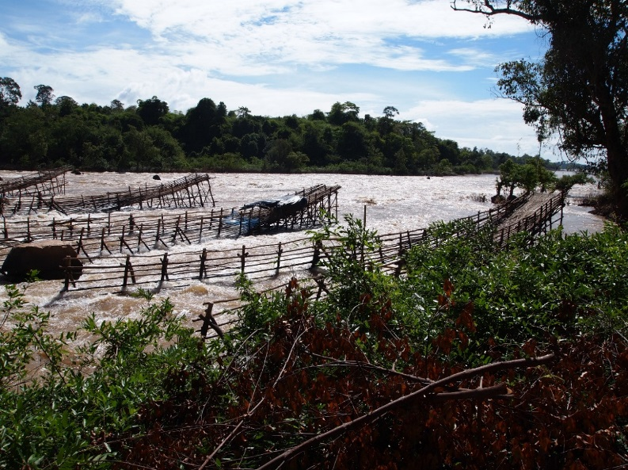

Fish Traps at 4000 Islands Mekong, Laos (Photo: Kristine Walløe-Lilleeng)
The forum is generously supported by:
