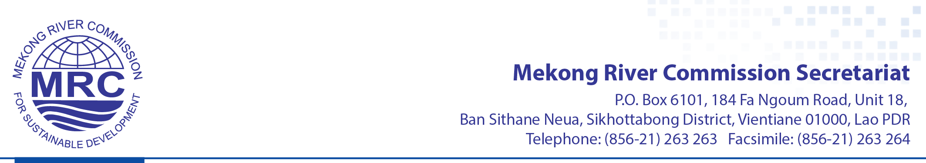

APPLICATION FORM

MRC Writing Contest
“What Does the Mekong Mean to You?”

Submission deadline: 15 March 2018

Part A: Personal information
1. Full name (as shown on your passport or ID):
Gender : Male Female Other:
First name :
Last name :
2. Date of birth (DD/MM/YY) :
3. Nationality :
4. Occupation :
5. Organization :
6. Present address (Street name) :
(City) :
(Postcode) :
(Country) :
7. Mobile (and office telephone) :
8. E-mail :

Part B: Your entry
Please use the lines below to enter your text, in no more than 60 words long. Please tell us what the Mekong River means to you and how important this connection is.

Part C: Acknowledgements
I, the undersigned, acknowledge that this entry is original, not plagiarized, and has never been published elsewhere. I understand that my entry may be rejected and become disqualified should it be found as containing plagiarism or copied materials or having been published previously.

Date: Signature:

Please send this completed application form by email or post to the following address:

Mekong River Commission Secretariat
Office of the Chief Executive Officer
Vientiane, Lao PDR
Tel: + 856 21 263 263
Fax: + 856 21 263 264
Email: writingcontest@mrcmekong.org

