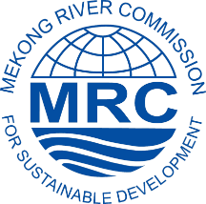
Sustainable Hydropower Practice Forum #4
Dialogue with Hydropower Developers

10-11 August 2017, Vientiane, Lao PDR

REGISTRATION FORM

Name: ………………………………………………………………………………………………..

Position: ………………..……………………………………………………………………………

Organization/association: ……………………………………………………………………………

Type of your organization/association:
☐ Government ☐ International NGO ☐ Private Sector ☐ Research Institution ☐ Other…………………………….........

Address:……………………………………………………………………………………………….

Tel/Fax/Email:………………………………………………………………………………………

Do you need a desk for publication display? ☐ NO ☐ YES

Any other request? ……………………………………………………………………………………
…………………………………………………………………………………………………............

Please return the filled form by 30 July 2017 to:
Mr. Palakorn Chanbanyong
Sustainable Hydropower Specialist, Office of the Secretariat in Vientiane
T: (856-21) 263 263 E:palakorn@mrcmekong.org

Ms. Duong Hai Nhu
Stakeholder Engagement Specialist, Office of the Secretariat in Vientiane
T: (856-21) 263 263 E:nhu@mrcmekong.org

