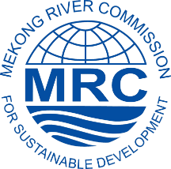
Registration FORM
The 2nd Regional Stakeholder Forum on
The Pak Beng Hydropower Project

Name: ………………………………………………………………………………………………..

Position: ………………..……………………………………………………………………………

Organization/association: ……………………………………………………………………………

Type of your organization/association:
☐ Government ☐ Local NGO ☐ International NGO ☐ Media ☐ Private Sector ☐ University/Academy ☐ Research Institution ☐ Other…………………………….........

Address:……………………………………………………………………………………………….

Tel/Fax/Email:………………………………………………………………………………………

Do you want to request a sponsorship for travel support?
☐ NO ☐ YES. Please provide reason ……………………………………………
…………………………………………………………………………………………………………
…………………………………………………………………………………………………............

Do you need a desk for publication display? ☐ NO ☐ YES

Any other request? ……………………………………………………………………………………
…………………………………………………………………………………………………............

Please return the filled form by 24 April 2017 to:
Ms. Duong Hai Nhu
Stakeholder Engagement Specialist, Office of the Secretariat in Vientiane
Tel: (856-21) 263263 | Email: nhu@mrcmekong.org

